Env-UAT  
https://fuzeuat.verizon.com/uat4spm/sites.jsp?siteId=617321024   
TC_01Verify Source Site field is displayed on Site Page UI under the Site Status  
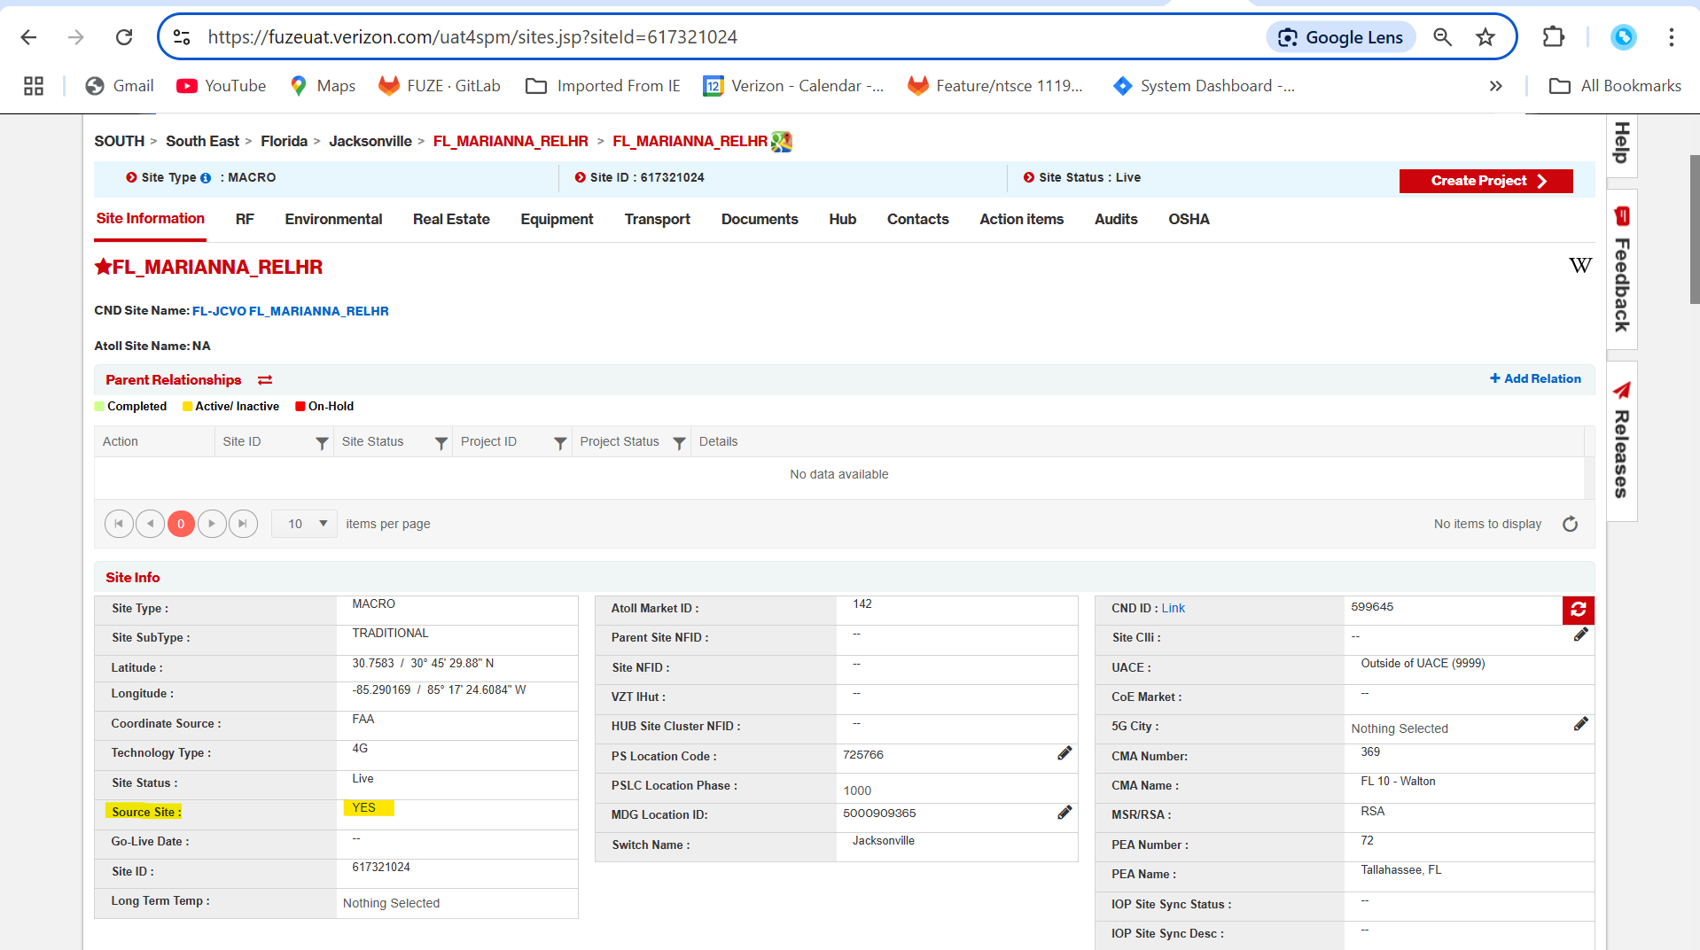  
TC_02Verify Source Site field is displayed in the site module in tracker  
